Human iPSC-Derived Oligodendrocyte Progenitor Cells Can Myelinate and Rescue a Mouse Model of Congenital Hypomyelination
- Su Wang¹,
- Janna Bates¹,
- Xiaojie Li¹,
- Steven Schanz¹,
- Devin Chandler-Militello¹,
- Corri Levine¹,
- Nimet Maherali²,
- Lorenz Studer³,
- Konrad Hochedlinger²,
- Martha Windrem¹,
- Steven A. Goldman^{1,}

Summary
Neonatal engraftment by oligodendrocyte progenitor cells (OPCs) permits the myelination of the congenitally dysmyelinated brain. To establish a potential autologous source of these cells, we developed a strategy by which to differentiate human induced pluripotent stem cells (hiPSCs) into OPCs. From three hiPSC lines, as well as from human embryonic stem cells (hESCs), we generated highly enriched OLIG2⁺/PDGFRα⁺/NKX2.2⁺/SOX10⁺ human OPCs, which could be further purified using fluorescence-activated cell sorting. hiPSC OPCs efficiently differentiated into both myelinogenic oligodendrocytes and astrocytes, in vitro and in vivo. Neonatally engrafted hiPSC OPCs robustly myelinated the brains of myelin-deficient shiverer mice and substantially increased their survival. The speed and efficiency of myelination by hiPSC OPCs was higher than that previously observed using fetal-tissue-derived OPCs, and no tumors from these grafts were noted as long as 9 months after transplant. These results suggest the potential utility of hiPSC-derived OPCs in treating disorders of myelin loss.

Highlights
► Myelinating oligodendrocyte progenitor cells (OPCs) were generated from human iPSCs ► hiPSC OPCs myelinated the brains of shiverer mice and increased their survival ► Myelination by hiPSC OPCs was faster than that of fetal-tissue-derived OPCs ► hiPSC OPCs produced both astrocytes and oligodendrocytes and were not tumorigenic
Figures and tables from this article:
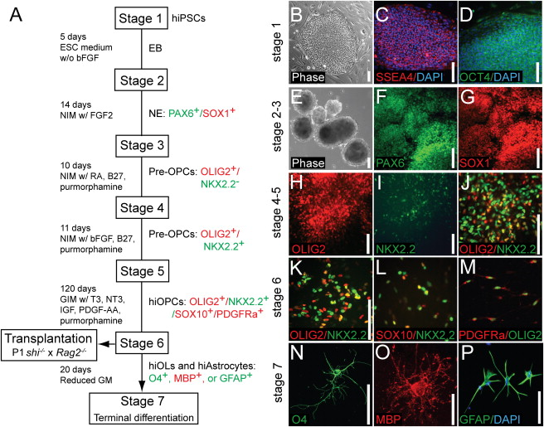
Figure 1. hiPSCs Can Be Directed into OPC Fate(A) A schematic protocol for directed differentiation of hiPSCs into OPCs. Embryoid bodies (EBs) were differentiated from undifferentiated hiPSCs (stage 1) from DIV 0–5. EBs were then differentiated as neuroepithelial (NE) cells in neural induction media (NIM; see Experimental Procedures) with bFGF.(B–D) Undifferentiated hiPSCs (stage 1) and hiPSC colonies expressed the pluripotency markers SSEA4 and OCT4. (B) Phase contrast. (C) SSEA4 (red); DAPI (blue). (D) OCT4 (green); DAPI (blue).(E–G) EBs (E) and neuroepithelial cells (F and G) could be generated from hiPSCs (stages 2 and 3). hiPSC-derived neuroepithelial cells at this stage expressed the neuroepithelial markers PAX6 and SOX1. (E) Phase contrast. (F) PAX6 (green). (G) SOX1 (red).(H and I) OLIG2⁺ and NKX2.2⁻ early glial progenitor cells appeared under the influence of retinoic acid (RA) and purmorphamine, a small-molecule agonist of sonic hedgehog signaling. By stage 4, OLIG2 was expressed in early pre-OPCs, which then serially developed NKX2.2 expression. (H) OLIG2 (red). (I) NKX2.2 (green).(J) OLIO2⁺/NKX2.2⁻ early pre-OPCs were differentiated into later-stage OLIG2⁺/NKX2.2⁺ pre-OPCs when RA was replaced by bFGF at stage 5. OLIG2 (red); NKX2.2 (green).(K–M) Pre-OPCs were further differentiated into bipotential OPCs in GIM (glial induction media; see Experimental Procedures) supplemented with PDGF-AA, T3, NT3, and IGF. Stage 6 was extended as long as 3–4 months for maximization of the production of myelinogenic OPCs. By the time of transplant, these cells expressed not only OLIG2 and NKX2.2 (K), but also SOX10 (L) and PDGFRα (M). By the end of stage 6, hiPSC OPCs could be identified as OLIG2⁺/NKX2.2⁺/SOX10⁺/PDGFRα⁺. (K) OLIG2 (red); NKX2.2 (green). (L) SOX10 (red); NKX2.2 (green). (M) PDGFRα (red), OLIG2 (green).(N–P) In vitro terminal differentiation of hiPSC OPCs into hiPSC-derived OLs (hiOLs), identified by O4⁺ (N) and MBP⁺ (O). OLs and GFAP⁺ astrocytes (P) arose with reduction in glial mitogens. (N) O4 (green). (O) MBP (red). (P) GFAP(green); DAPI (blue).Scale: 100 μm (B–N, P) and 25 μm (O). See also Figure S1.
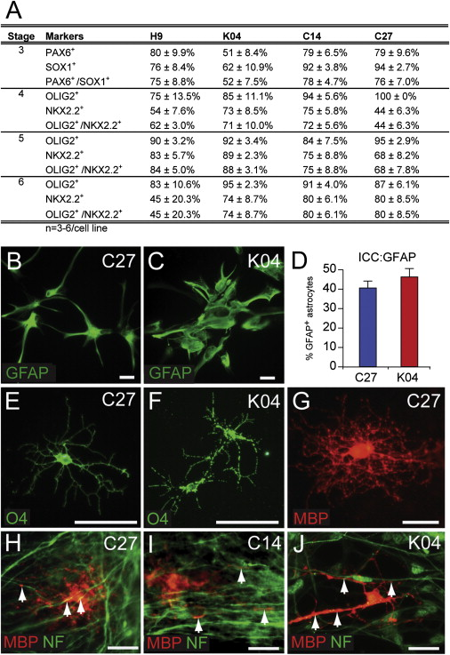
Figure 2. Both Astrocytes and OLs Are Efficiently Generated from hiPSC OPCs(A) Expression of neural markers during induction of oligodendroglial-lineage hiPSC-derived neuroepithelial cells in stage 3, pre-OPCs in stages 4 and 5, and OPCs in stage 6. Cultures were immunostained for PAX6 and SOX1, or OLIG2 and NKX2.2, respectively. The proportion of immunopositive clusters for each marker set were scored for each hiPSC line. At least three repeats in each group were performed; data are provided as means ± SEM. In stage 6, gliogenic clusters were dissociated to single-cell suspensions and plated in GIM, resulting in the terminal differentiation of both astrocytes and myelinogenic OLs.(B and C) GFAP⁺ astrocytes were evident in cultures of hiPSC OPCs by 95 DIV; C27-derived (B) and K04-derived (C) astrocytes are shown here.(D) Proportion of GFAP⁺ astrocytes among all cultured cells at 95 DIV; the remainder expressed oligodendroglial lineage markers (means ± SEM; see Figure S2I). ICC, immunocytochemistry.(E–J) Later in stage 6 (160 DIV), hiPSC-derived OPCs differentiated as both O4⁺ (F and G) and MBP⁺ (G) OLs. (H–J) When cocultured with human fetal cortical neurons, hiPSC OPCs derived from C27 (H), C14 (I), and K04 (J) hiPSCs all generated MBP⁺ myelinogenic OLs that engaged NF⁺ axons (MBP, red; NF, green).Scale: 50 μm. See also Figure S2.
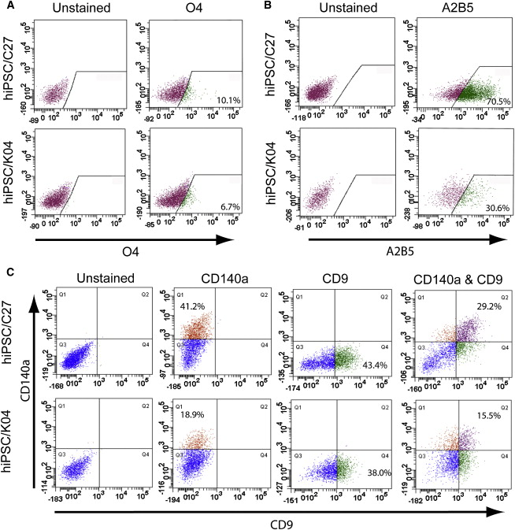
Figure 3. OPCs Can Be Isolated from Mixed hiPSC Culture by CD140a- and CD9-Directed FACS(A) hiPSC OPC-derived OLs were recognized and isolated by FACS using monoclonal antibody O4, which recognizes oligodendrocytic sulfatide. The incidence of O4⁺ oligodendroglia varied across different hiPSC lines, from 4% to 12% (see Table S1; n = 4–7 experiments).(B) OPCs derived from hiPSCs (C27 and K04) were readily recognized with the cell-surface marker A2B5.(C) OPCs derived from either hiPSCs (C27 and K04) or hESCs (WA09/H9) were readily recognized with cell-surface markers, PDGFRα (CD140a), and CD9 by FACS analysis. The relative proportions of CD140a, CD9, and CD140a/CD9 double-labeled cells varied across the different cell-line-derived OPCs (n = 4–7 experiments).See also Tables S1A and S1B.
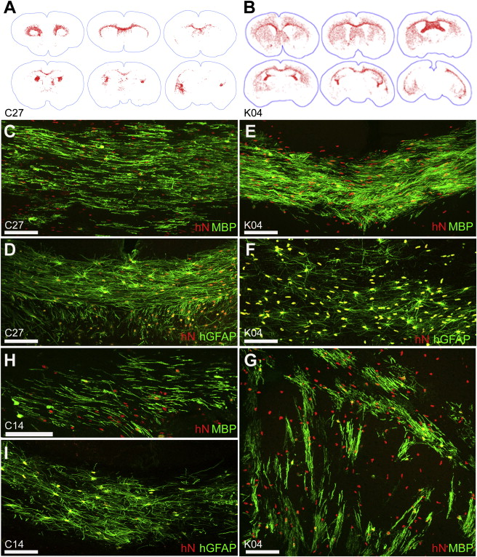
Figure 4. hiPSCs Migrate Widely and Differentiate as Astroglia and Myelinogenic OLshiPSC OPCs generated from all three hiPSC lines migrated throughout the shiverer brain, engrafting most densely in white matter. Distributions of C27 (A) and K04 (B) hiPSC-derived OPCs are shown (hNA⁺, red, mapped in Stereo Investigator). By 13 weeks of age, C27 hiPSC OPCs (C), K04 hiPSC OPCs (E and G), and C14 hiPSC OPCs (H) matured into MBP-expressing oligodendroglia (green) throughout the subcortical white matter, including callosal and capsular (C, E, and H) as well as striatal (G) tracts. In these 13-week-old shiverer mouse recipients, C27 (D), K04 (F), and C14 (I) hiPSC-derived OPCs also differentiated as astroglia (human-specific GFAP, green), especially as fibrous astrocytes in the central white matter.Scale: 100 μm (C–I). See also Table S2.
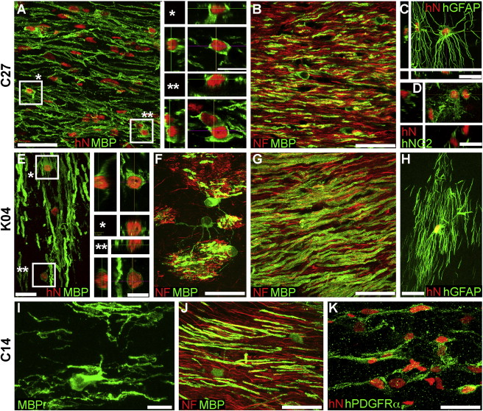
Figure 5. hiPSC OPCs Robustly Myelinate In VivoConfocal images of the callosal and capsular white matter of mice engrafted with hiPSC OPCs derived from all three tested hiPSC lines demonstrate dense donor-derived myelination: (A and B) C27-derived, (E–G) K04-derived, and (I and J) C14-derived. (A), (G), and (J) show abundant, donor-derived MBP expression (green) by C27, K04, and C14 hiPSC OPCs (hNA, red), respectively. Representative z stacks of individual hNA⁺ OLs are shown as asterisks in (A) and (E). By the 19 week time point assessed here, C27 (B), K04 (F and G), and C14 (J) hiPSC oligodendroglia robustly myelinated axons (NF, red). hiPSC-derived oligodendroglial morphologies are exemplified in panels (F) (K04) and (I) (C14); (F) shows multiaxon myelination by single OLs in the striatum.hiPSC OPCs also generated astroglia (C, C27; H, K04), which exhibited the complex fibrous morphologies typical of human astrocytes (human-specific GFAP, green). Many cells also remained as progenitors, immunostaining for NG2 (D, C27) and human-specific PDGFRα (K, C14).Scale: 50 μm (A–C, G, J); 20 μm (C–F, H, K); and 10 μm (I, insets to A and E).
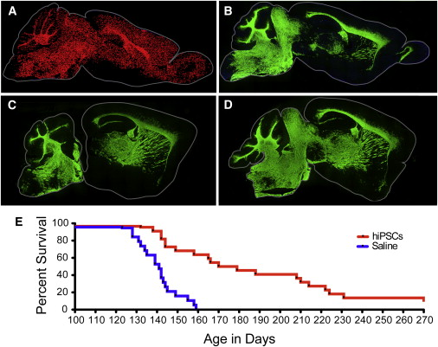
Figure 6. hiPSC OPCs Myelinate Widely to Greatly Extend the Survival of Hypomyelinated Mice(A) Dot map indicating the distribution of hiPSC-derived donor cells (C27) at 7 months of age, following neonatal engraftment in a shiverer mouse brain. Widespread dispersal and chimerization by hiPSC OPCs is evident (hNA, red).(B) hiPSC-OPC-derived myelination in a shiverer forebrain at 7 months; section 1 mm lateral to (A). MBP immunoreactivity (green) is all donor derived.(C and D) Myelination in sagittal sections taken at different mediolateral levels from two additional 7-month-old mice, each engrafted with C27 hiPSC OPCs at birth.(E) Kaplan-Meier plot of the survival of C27 iPSC-OPC-implanted (n = 22) versus saline-injected (n = 19) control mice. Remaining engrafted mice sacrificed for electron microscopy at 9–10 months (≥270 days).Scale: 2 mm (A and B). See also Figure S3.
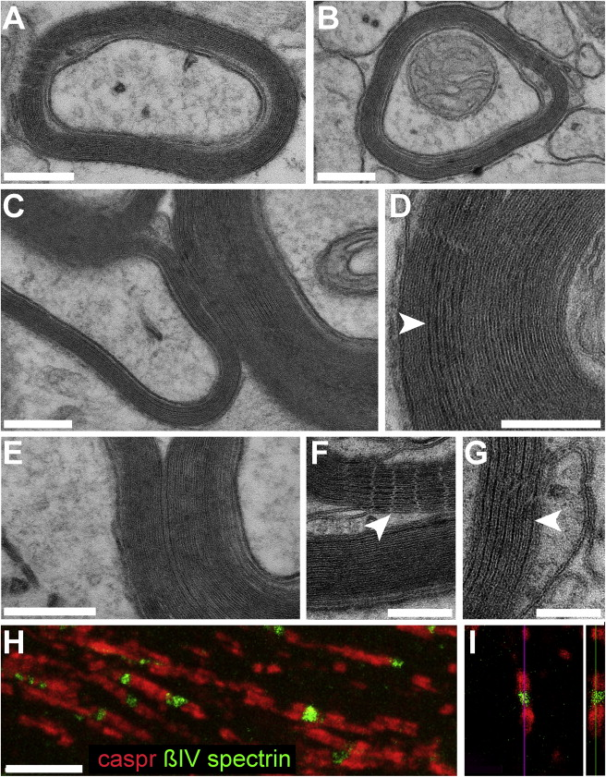
Figure 7. hiPSC-Derived OLs Produce Compact Myelin and Induce Nodes of RanvierRepresentative electron microscopic images of sections through the corpus callosum (A and B) and ventral pons (C) of a 40-week-old shiverer mouse neonatally engrafted with C27 hiPSC OPCs, showing donor-derived compact myelin with evident major dense lines, ensheathing mouse axons.(D–G) Higher-power images of donor-derived myelin in the corpus callosum, also at 40 weeks. (D and E) The alternating major dense (arrowheads) and intraperiod lines, characteristic of mature myelin, are evident. (F and G) Myelin sheaths in the corpus callosum ensheathing central axons are shown, their maturation manifested by parallel arrays of tight junctions (F, arrowhead) and major dense lines (G, arrowhead).This mature myelination permitted the organization of architecturally appropriate nodes of Ranvier by hiPSC oligodendroglia. In (H) and (I), nodal reconstitution in transplanted shiverers is demonstrated by immunostaining of oligodendrocytic paranodal Caspr protein (red), seen flanking nodes of Ranvier identified here by ßIV spectrin (green). An isolated node is shown in confocal cross-section in (I).Scale: 200 nm (A–E); 100 nm (F and G); and 5 μm (H and I). See also Figure S4.

